**Challenge 2**

Based on the recorded lecture, replicate the following screen shots emphasizing individuality

Apply css

Remember to try applying divisions to your pages, this will help format it with css

In the folder where you will save the html notepads, create another folder images for easy accesibility

**Page 1: home page**

Links to page 2: menu page via the word menu

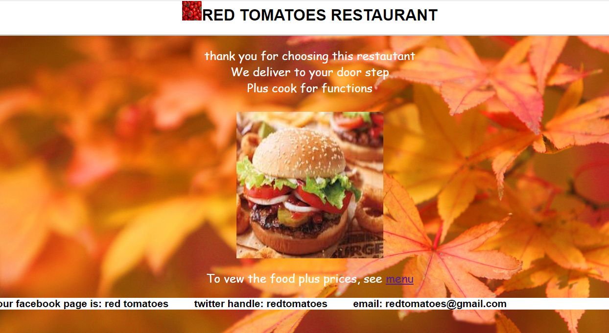

**Page 2: Menu page**

Include a table to show a menu

Links to form page and home page

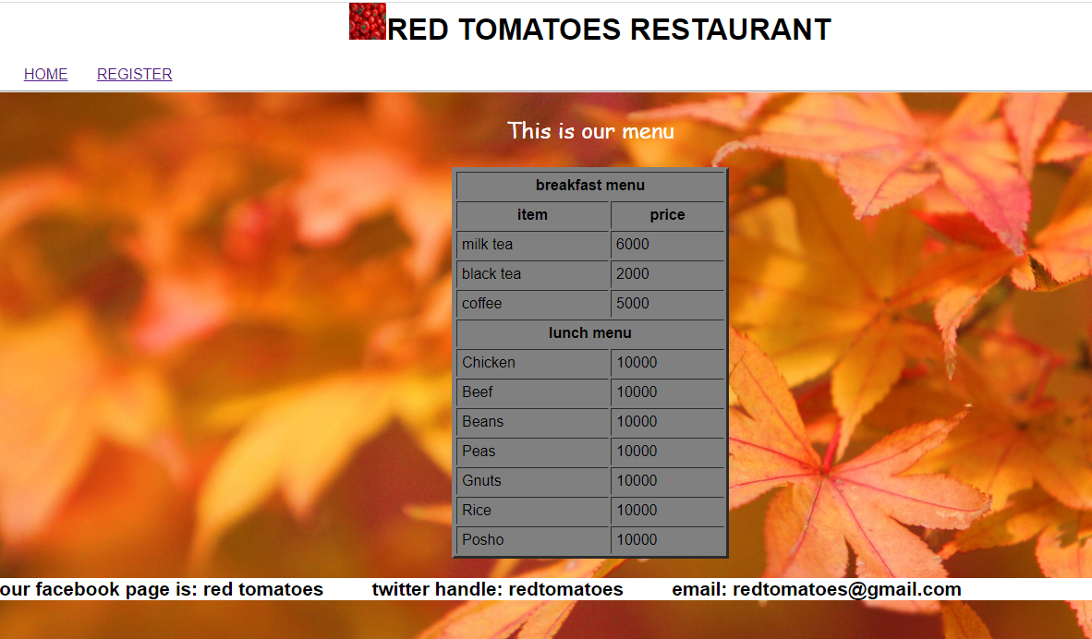

**Page 3: Forms page**

Include a form

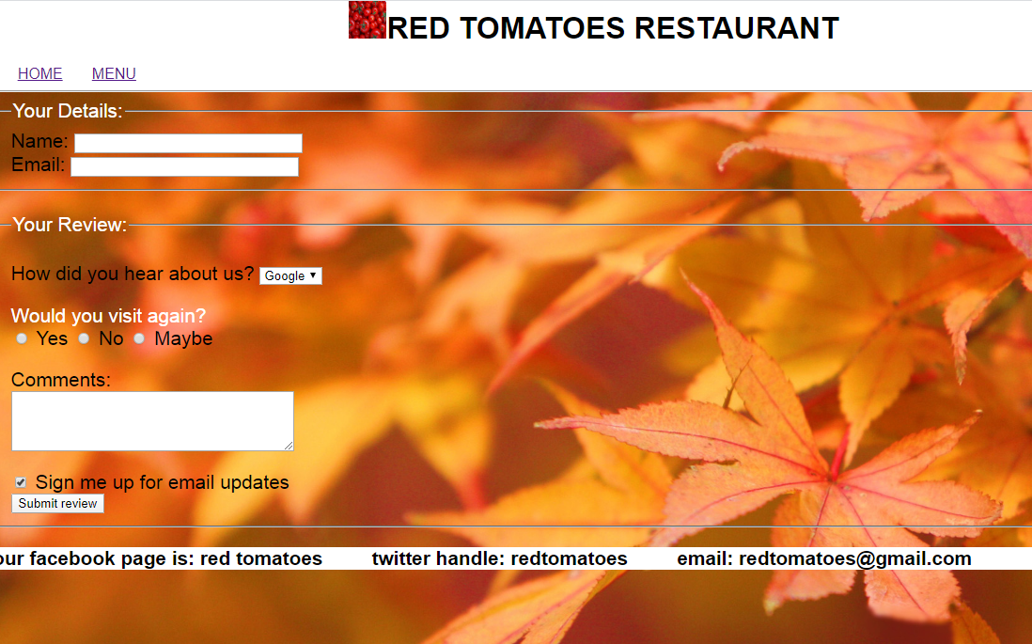

To be presented on 16th Feb for day and 18th Feb march for evening along with challenge 1